1.

Frequency Table - Time in Campus

|  |  |  |  |
| --- | --- | --- | --- |
| **Time in Campus** | **Frequency** | **Relative Frequency** | **Cumulative Frequency** |
| 55 | 1 | 0.1 | 0.1 |
| 60 | 1 | 0.1 | 0.2 |
| 65 | 1 | 0.1 | 0.3 |
| 70 | 2 | 0.2 | 0.5 |
| 80 | 1 | 0.1 | 0.6 |
| 85 | 2 | 0.2 | 0.8 |
| 90 | 1 | 0.1 | 0.9 |
| 95 | 1 | 0.1 | 1.0 |

2.

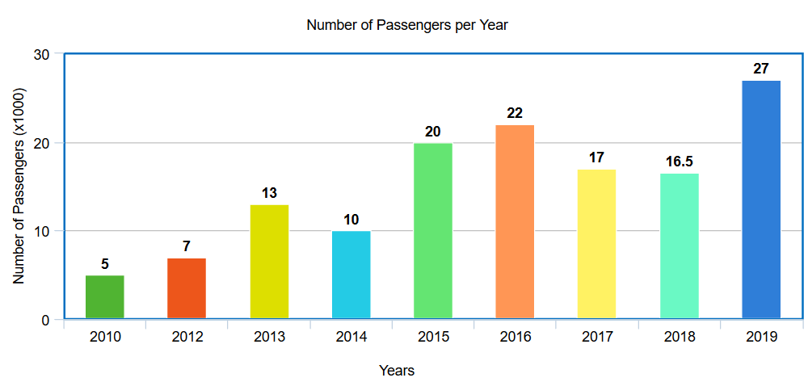

3. 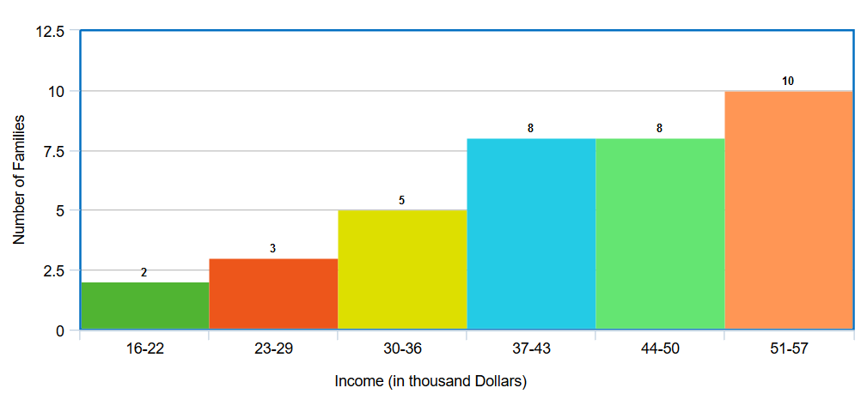

**Conclusion**: Income has a positive effect on the number of families. In other words, increasing income will most probably increase people to start families (marry).